Winsock is above the TCP/IP protocol stack in the ISO/OSI model. TCP/IP is an industry standard communication protocol that defines methods for packaging data into packets for transmission between computing devices on a heterogeneous network. TCP/IP is the standard for data transmission over networks, including the Internet. TCP establishes a connection for data transmission and IP defines the method for sending data packets.

The Microsoft Winsock control makes using the TCP/IP a breeze. Microsoft has wrapped up the Winsock and INetAPI API calls into a nice neat package that you can easily incorporate into your Visual Basic applications.
WINSOCK OPERATING MODES

The Transport layer (also known as the Host-to-Host Transport layer) is responsible for providing the Application layer with session and datagram communication services. The core protocols of the Transport layer are TCP and User Datagram Protocol (UDP). The Winsock control supports the following two operating modes (can be set using PROTOCOL property):

- sckTCPProtocol
- sckUDPProtocol
(a) TCP APPLICATION: -
SERVER CLIENT
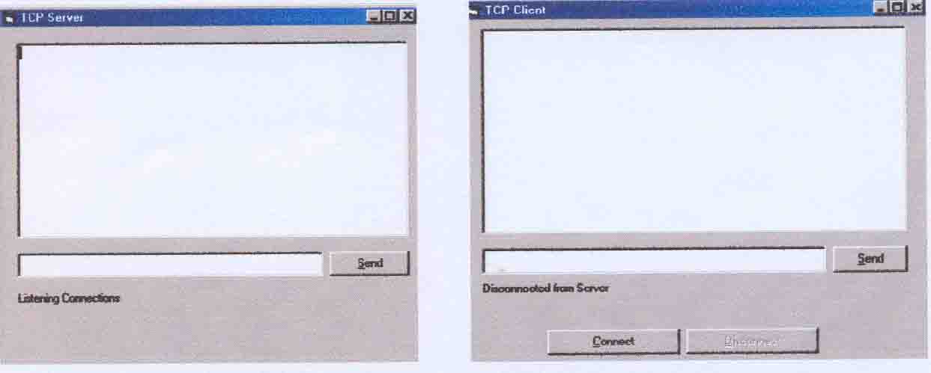
Server Coding: -

Private Sub cmdSend_Click()
If Not (lblStatus.Caption = "Listening Connections") Then
If Trim (txtSend.Text) <> "" Then wscTCPServer.SendData txtSend.Text
txtMessages.SelText = vbCrLf + "Server says: " + txtSend.Text
lblStatus.Caption = "Message Sent"
End If
txtSend.Text = “”
End If
End Sub

